**Chapter 6: Multiple Linear Regression**

* Matrix form estimation, prediction, and inference
* Simple vs multiple regression: residual plot and scatter plot

**Chapter 7: General Linear F-test and Multicollinearity**

* Concept behind general linear test.
* Explain and interpret Type I and Type II SS.
* Explain and interpret partial correlations: .
* Explain the concept behind standardized regression.
* Explain source (linear dependence of columns) and consequence (less accurate estimation of individual -values, but prediction is unaffected [why?]) of multicollinearity.

**Chapter 8: Special Model**

* Case I: quadratic regression/multicollinearity.
  + Solution: First centering predictors and then introducing quadratic terms.
* Case II: interaction model with binary predictor.
  + Example: ( is continuous and is binary). Interpret meaning of coefficients and how to perform a general linear F-test on this model.
* Case III: Interaction model with continuous predictor. Have a conceptual understanding of meaning of interaction.
* Case IV: Code categorical variable.
  + A predictor with classes requires dummy variables. Example below:

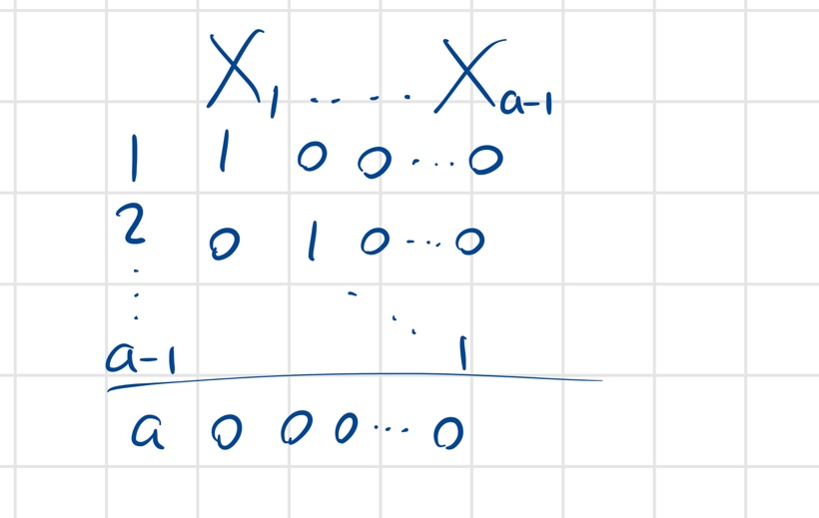

* IGNORE CONSTRAINED REGRESSION

**Chapter 9: Model Selection**

* Goal: to find a simple model that fits well
* (write down formula and interpret)
* Adjusted
* value (don’t need to do by hand but understand concept)
* Search base regression: execute by hand (for example, describe 1 step of forward selection) and explain relationship with Type II SS.
* IGNORE LASSO AND CROSS VALIDATION

**Chapter 10: Model Diagnoses**

* Partial regression plot (visualization of partial regression) to diagnose “true” relationship
* Studentized residuals and studentized deleted residuals. They are distributed by
* Definition and interpretation of leverage ()
* Influential Statistics
  + DFFIITS
  + Cook’s Distance
  + DFBETAS
  + Rule of Thumb
  + Know equations on the slides
* Know definition and interpretation of VIF, also know rule for comparison.

**Chapter 11: Model Remedies**

* Know concept and definition of weighted least squares estimate: where is a diagonal matrix of weights and is proportional to . Why use WLS?
* Concept: how to estimate weights/use residuals
* Ridge Regression (don’t write the equation down): handle multicollinearity w/o dropping predictors. Know how to interpret and how to read a ridge plot
* Bootstrapping: know purpose (derive inference for nonstandard estimates/nonstandard situations), main idea (simulate data from pseudo “true” populations)